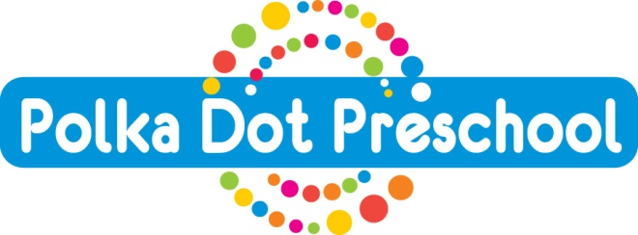

Polka Dot Parent Handbook
ANAPHYLAXIS INDIVIDUAL ACTION PLAN

CHILD’S NAME: __________________________ DATE OF BIRTH: ___________________
MY CHILD’S ANAPHYLAXIS TRIGGERS ARE: (Tick all that apply)
Peanuts _____ Nuts (Please specify) __________________________________
Milk____ All Dairy _____ Eggs _______ Shellfish _______ Fish_______
Food Additives _____ (Please specify) _________________________________
Insect Stings _____ (Please specify) _________________________________
Medications _____ (Please specify) _________________________________
Others _____ (Please specify) _________________________________

MY CHILD’S ANAPHYLAXIS SYMPTOMS USUALLY ARE:
___ swelling (eyes, lips, face, tongue) ___ difficulty breathing or swallowing
___ Cold, clammy, sweaty skin ___ flushed face or body
___ fainting or loss of consciousness ___ vomiting
___ coughing or choking ___ stomach cramps, diarrhea
___ Dizziness, confusion ___ change of voice, hoarseness
___ Other (be specific) _______________________________________________________
_______________________________________________________
MY CHILD’S EMERGENCY TREATMENT IS:
___ Epi-Pen Expiry Date: ___________________
___ Epi-Pen Expiry Date: ___________________

PROCEDURE TO FOLLOW IN AN EMERGENCY SITUATION:
__________________________________________________________________________________________________________________________________________________________________________________________________________________________________________

I, _____________________, authorize the Director, ______________________, to conduct
(Parent’s Name)
subsequent training when needed to new staff and volunteers regarding my child’s Action Plan and Administering of the Epi-Pen.

Parent/Guardian Signature ______________________ Date: __________________

Director’s Signature: ____________________________ Date: __________________

PARENTS’ AVOIDANCE STRATEGIES

PARENTS’ EMERGENCY CONTACT INFORMATION
PARENT’S NAME | MOTHER | FATHER
HOME NUMBER
CELL NUMBER
WORK NUMBER
ALTERNATE NUMBER

I understand that by completing this form:

- I am giving Polka Dot Preschool staff the authorization to administer the Epi-Pen to my child if required.

- The staff at Polka Dot Preschool will call 911 immediately if my child is having an Anaphylactic Allergic Reaction.

- That Polka Dot Preschool will follow the necessary procedures whether myself or the emergency contacts can be reached or not.

- Parents are responsible for informing Polka Dot Preschool if there are any changed required to this form.

- Polka Dot Preschool will require this form to be reviewed annually with parents.

***I, _______________________, have trained the staff below, on my child’s Individual
(Parent’s Name)

Anaphylaxis Action Plan and Administering of the Epi-Pen.

Staff Name | Date of Training

